**Unix Operating System**

**Basic commands**

* **Passwd**

Thiscommand changes passwords for user accounts of UnixOS.

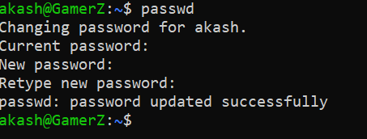

* **ls**

This command will list file name

**Options** :

-**l** : use a long listing format  
 -**s** : print the allocated size of each file, in blocks  
 -**S** : sort by file size

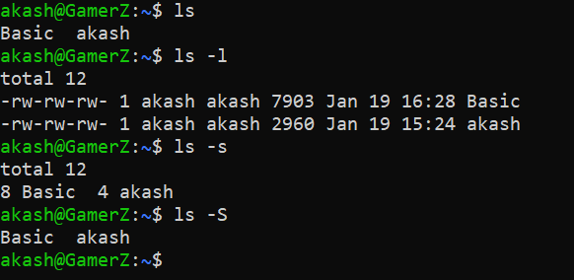

* **whoami**

It displays the username of the current user when this command is invoked.

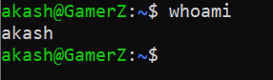

* **tty**

**tty** is a command in Unix and Unix-like operating systems to print the file name of the terminal connected to standard input. tty stands for TeleTYpewriter.

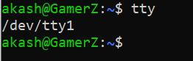

* **stty**

**stty** command in Linux is used to change and print terminal line settings. Basically, this command shows or changes terminal characteristics**.**

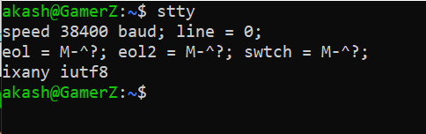

* **uname**

**uname** (short for unix name) is a computer program in Unix and Unix-like computer operating systems that prints the name, version and other details about the current machine and the operating system running on it.

**Options:**

**-v**: It prints the version of the current kernel  
 **-o**: It prints the name of the operating system.

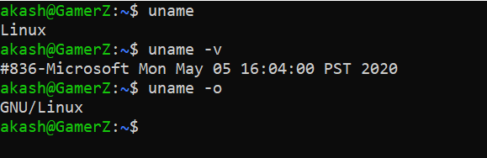

* **date**

**date** command is used to display the system date and time. date command is also used to set date and time of the system. By default the date command displays the date in the time zone on which unix/linux operating system is configured.

**Options**:

%**Y** : Year (e.g., 2020)  
 %**m** : Month (01-12)  
 %**d** : Day of month (e.g., 01)

%**D** : Display date as mm/dd/yy  
%**T** : Display time as hh/mm/ss

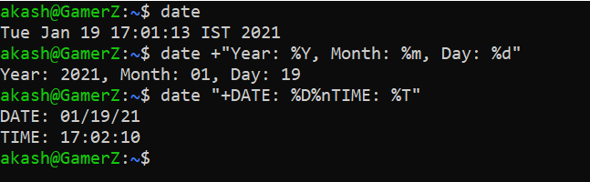

* **cal**

To display current month's calendar

**Options**:

-3 : display prev/current/nextMonth calendar

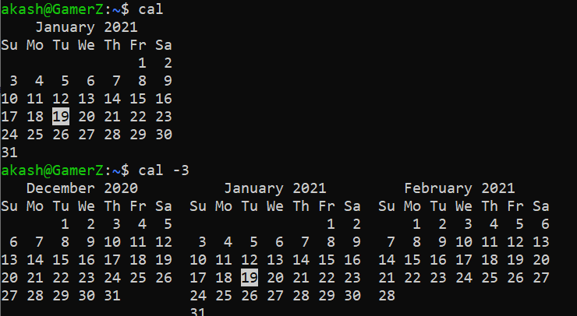

* **bc**

**bc** command is used for command line calculator. It is similar to basic calculator by using which we can do basic mathematical calculations.

Functions Supported:

**scale**: The value of the scale function is the number of digits after the decimal point in the expression.  
**ibase** : Convert Binary to Decimal

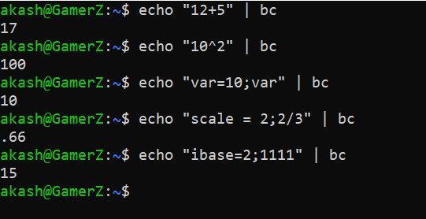

* **echo**

**echo** command is used to display line of text/string that are passed as an argument . This is a built in command that is mostly used in shell scripts.

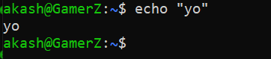

* **cat**

**Cat(concatenate)** command is very frequently used in Linux. It reads data from the file and gives their content as output. It helps us to create, view, concatenate files

